**Aim:** Working over Tableau

**IDE:** Microsoft Excel , Tableau

**Questions:**

* First in Order Sheet of Dataset Insert Name of Customers ,Gender,city,country from Customer Id and from Customer Sheet.

1. 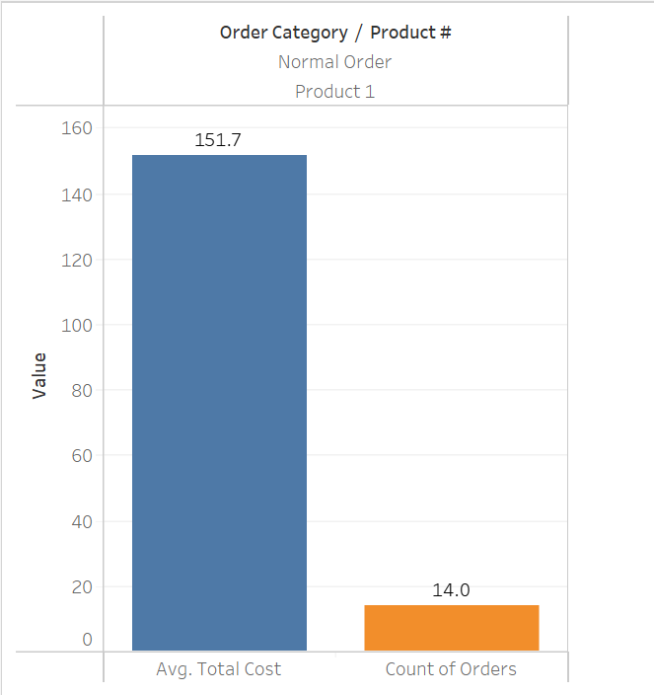**Average "total cost" and count of the product 1 under normal order category**
2. **Average "total cost" and count of the product 1 under short order category**

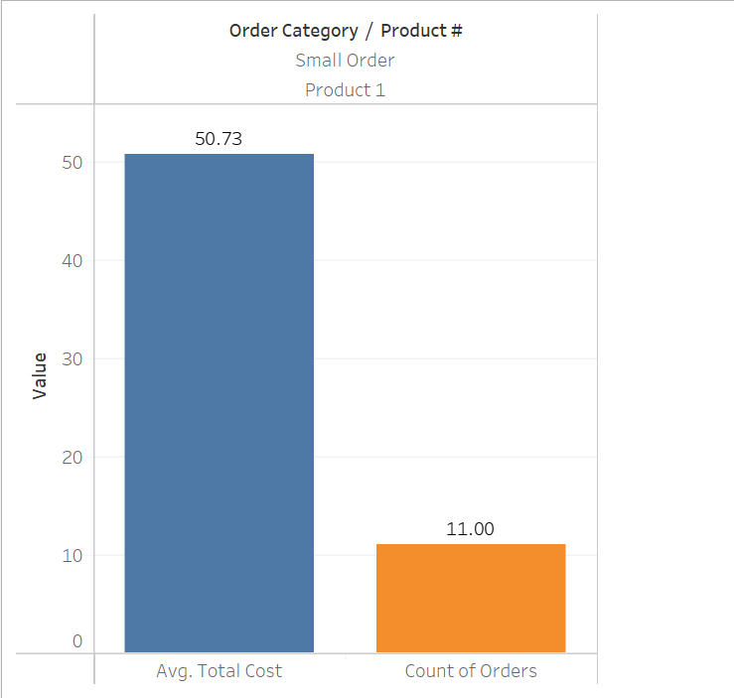

1. 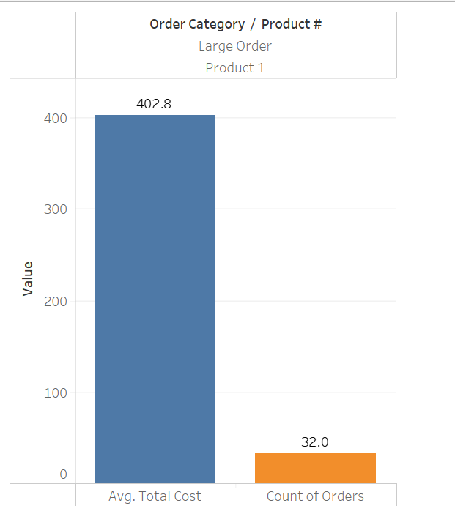**Average "total cost" and count of the product 1 under large order category**
2. 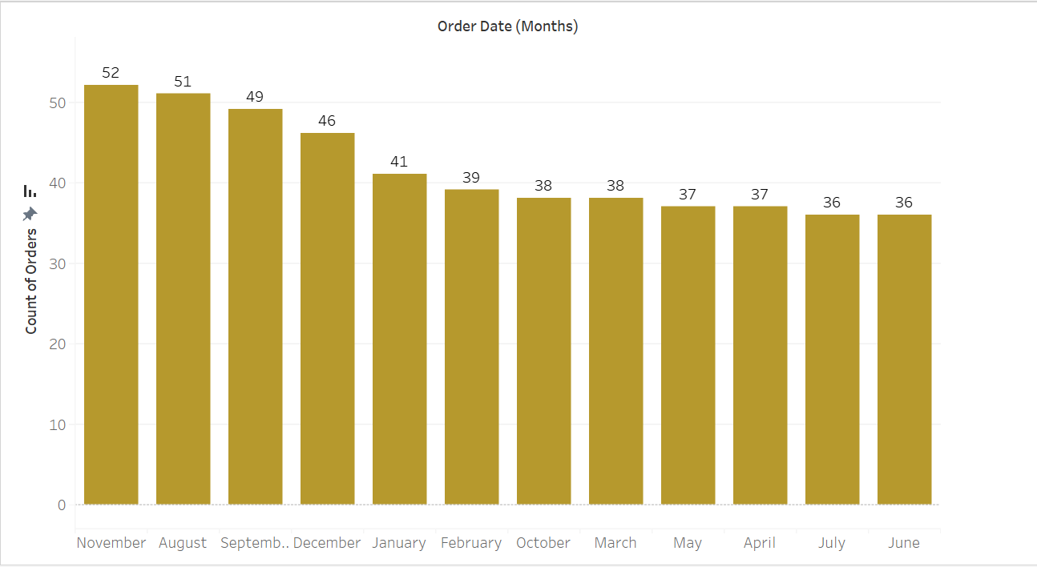**Which month has the highest count of orders placed**
3. 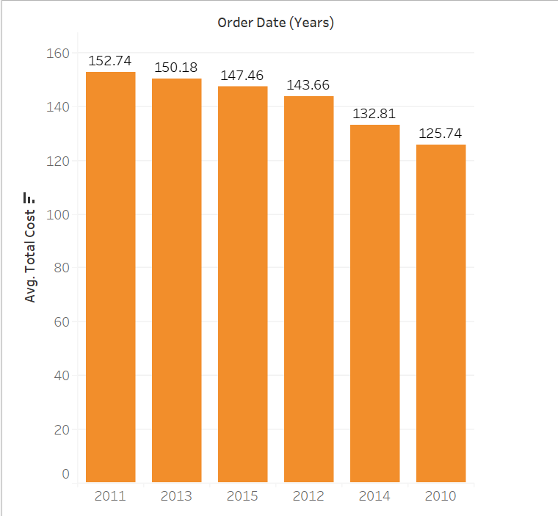**Which year has the highest "average total cost"?**
4. **What is the ratio of the number of orders placed by male and female?**

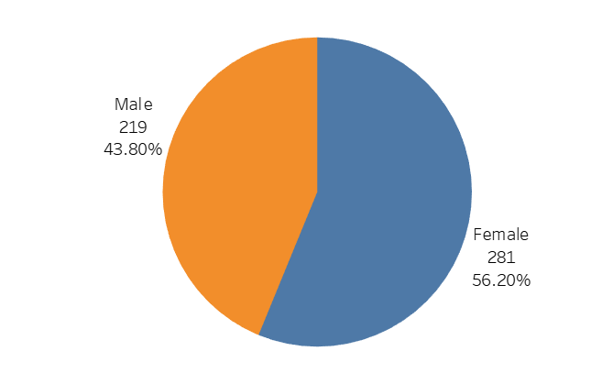

1. 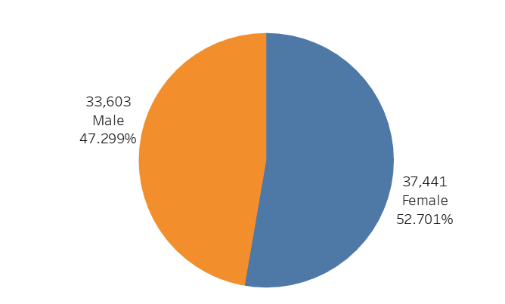**What is the ratio of the total cost of the orders placed by male and female?**
2. 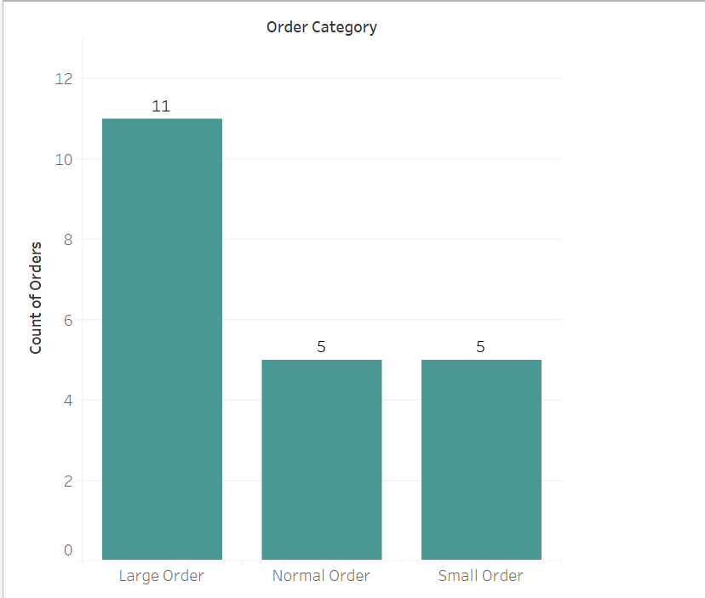**How many orders are placed under each order category for the country "INDIA"?**
3. 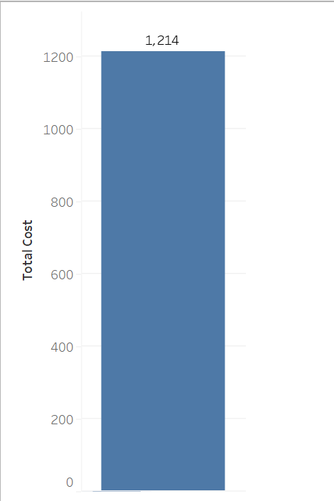**What is the total cost of the order placed by the customer "Willis Brinks"?**
4. **Name the customer who has placed the order with the highest amount.**

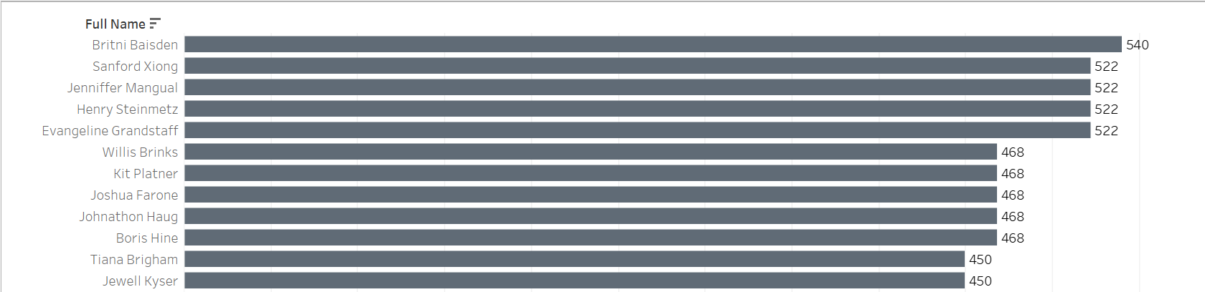

1. 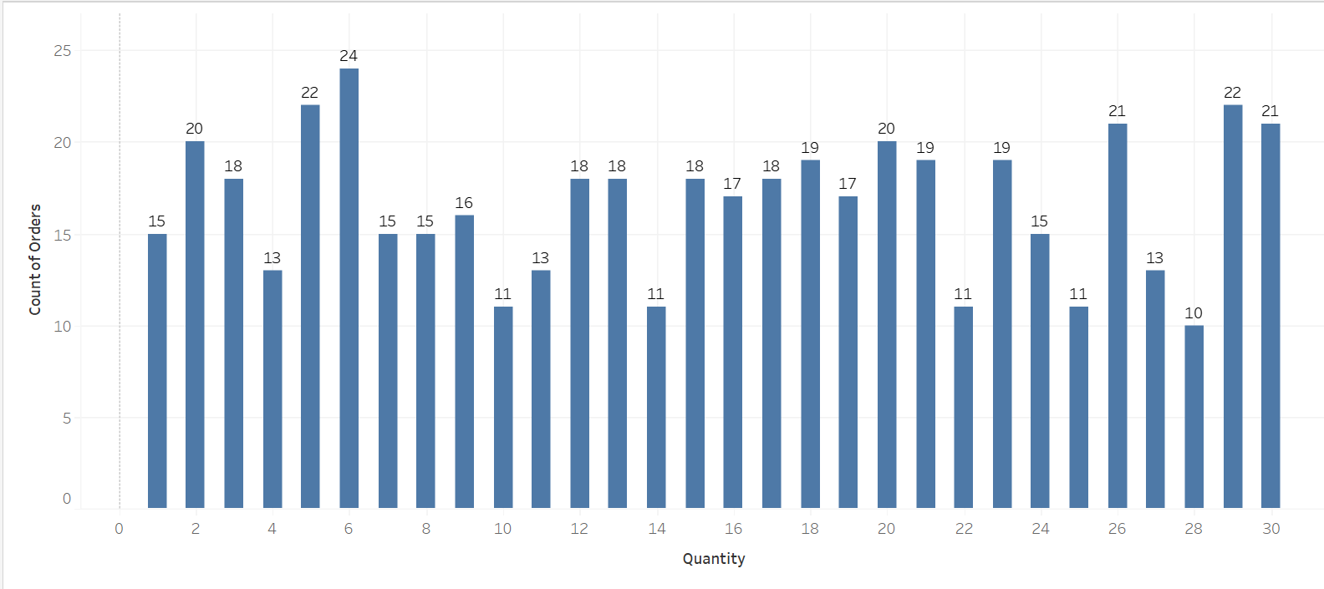**What is the most common order quantity?**
2. 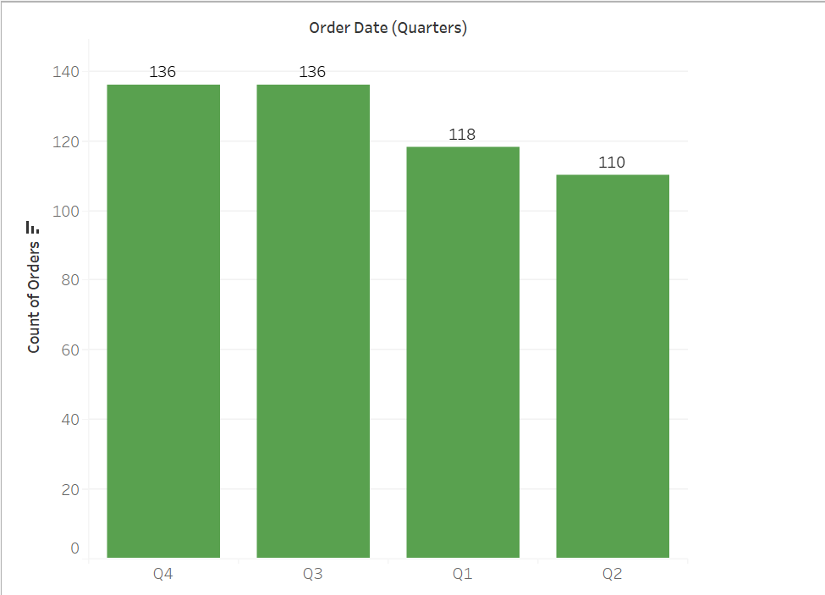**Are there specific quarters with higher order volumes?**
3. 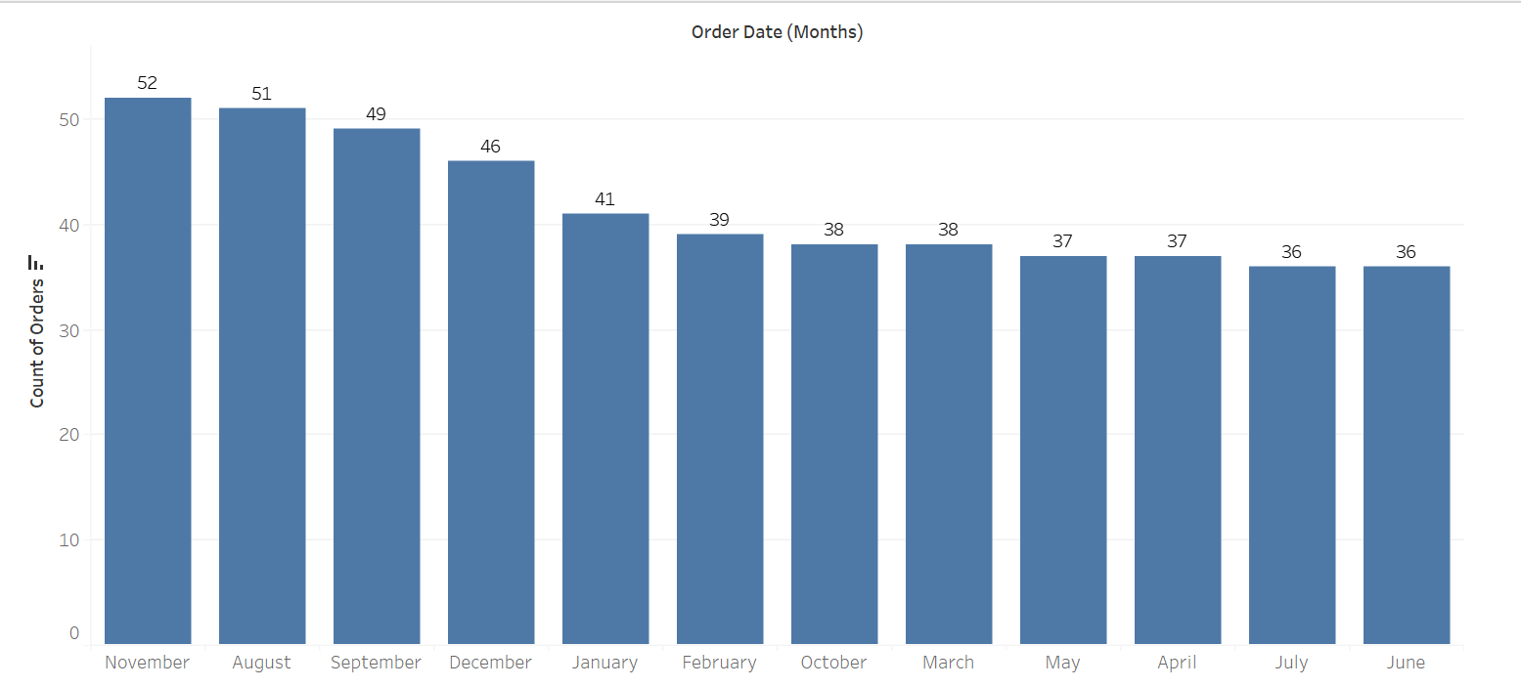**How does order frequency vary over the month?**
4. **Are there certain categories contributing more to revenue?**

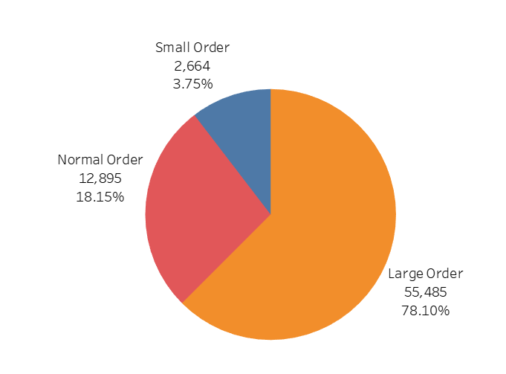

1. 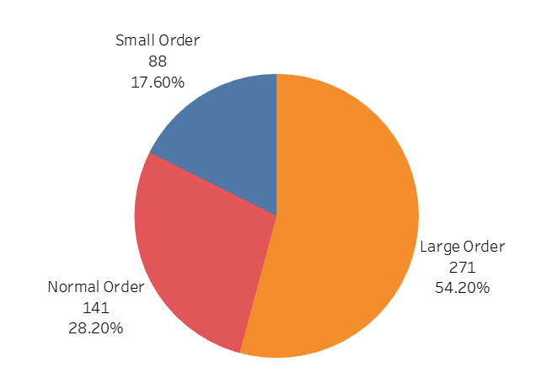**What is the distribution of orders across different order categories?**
2. **Can you identify the most common product purchased in large orders?**

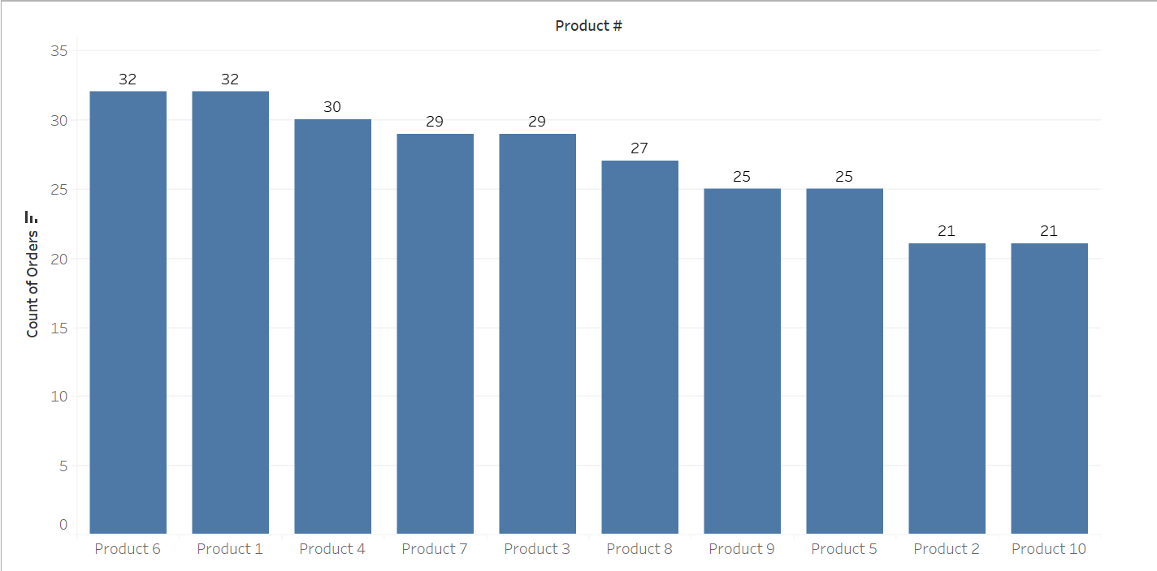

1. 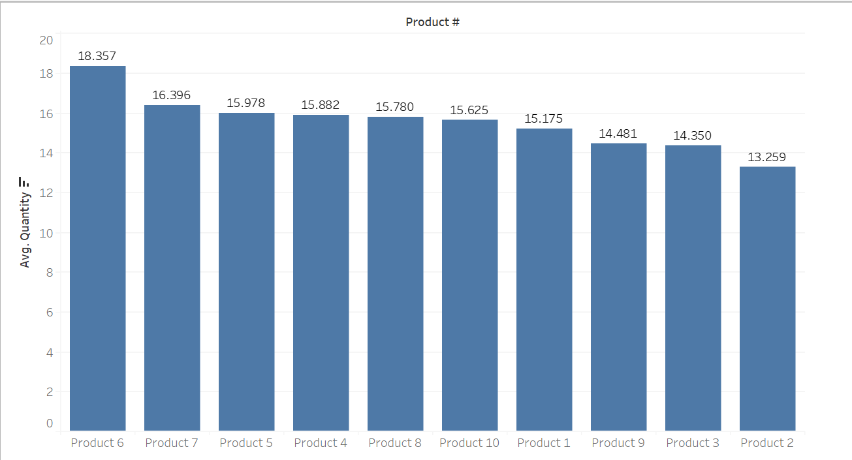**What is the average quantity of products per order?**
2. **Which product has the highest unit price?**

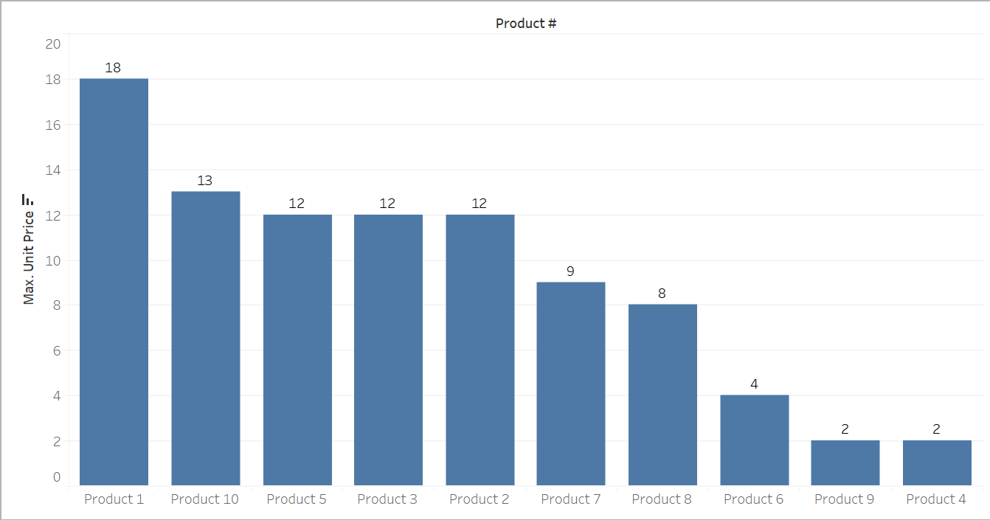

1. **What is the total revenue generated from large orders versus normal orders?**

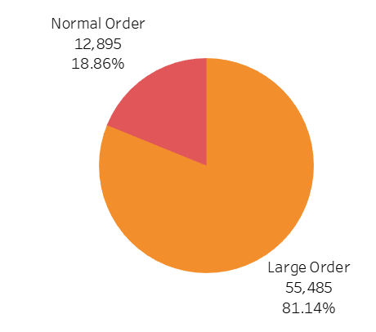

1. **What is the proportion of large orders to normal orders in the dataset?**

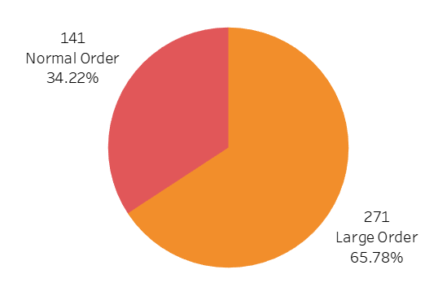

1. 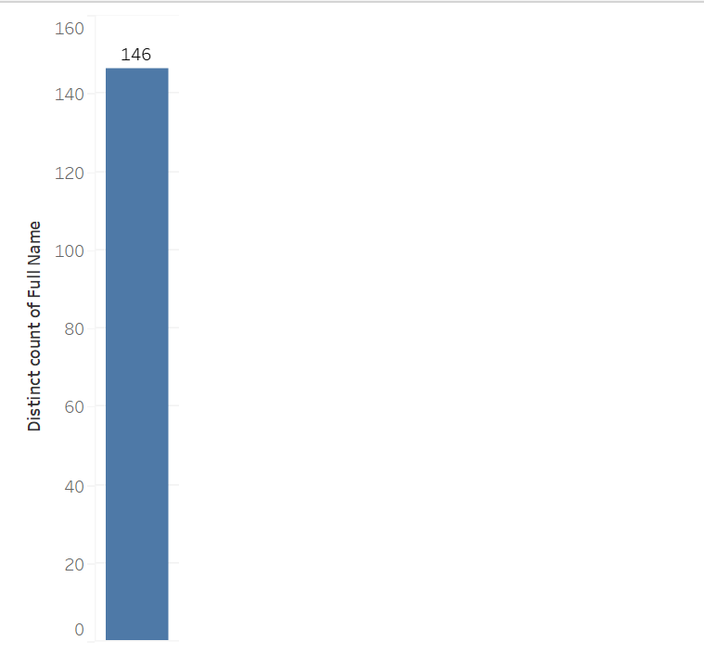**How many unique customers are represented in the dataset?**
2. **What is the most frequently purchased product across all orders?**

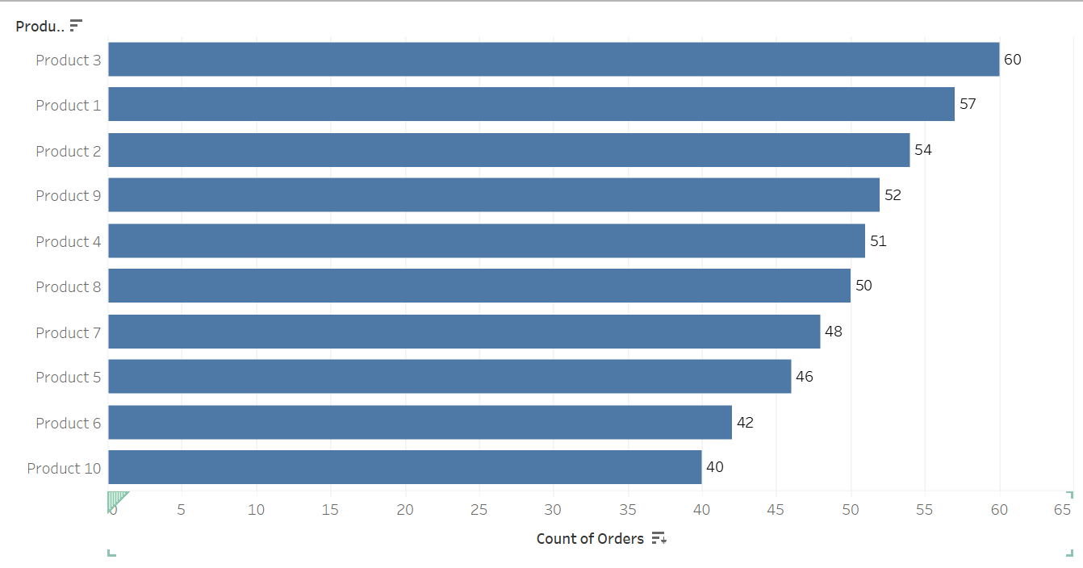

1. 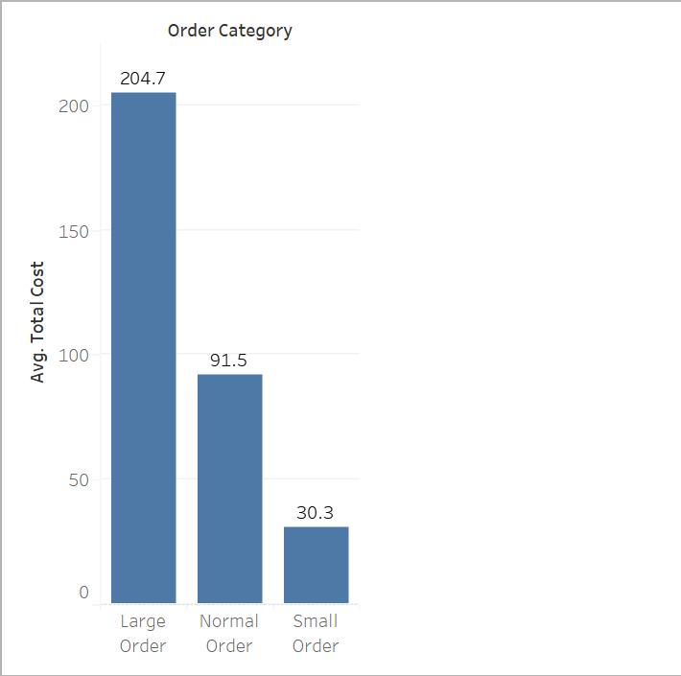**What is the average total cost for each order category?**
2. **How does the quantity of products impact the total cost in different order categories?**

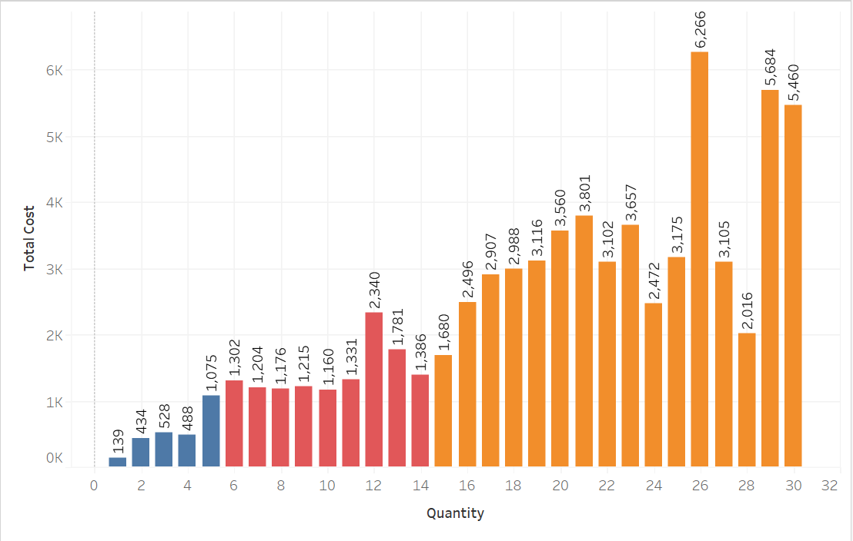

**25) What is the proportion of small, normal, and large orders in the dataset?**

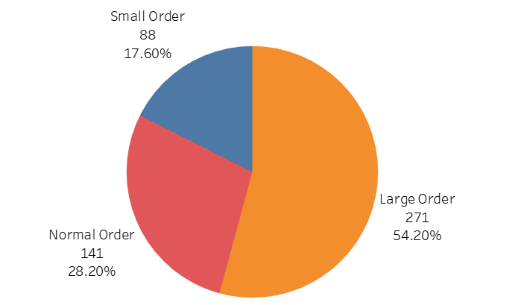

**Observation and Learnings:**

By Attempting this assignment I Learnt The Data visualization Using Tableau.